**Coding Challenge – Hospital Management By Pradeksha R K (P319)**

I have defines `Patient` class with the following confidential attributes and inserted some rows to it.

a. patientId

b. firstName

c. lastName;

d. dateOfBirth

e. gender

f. contactNumbe

g. address

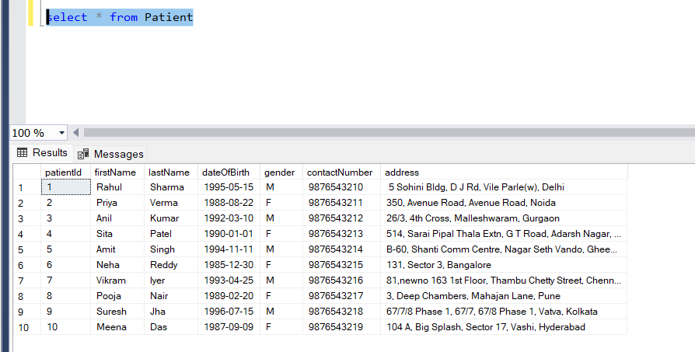

I have Define ‘Doctor` class with the following confidential attributes and inserted some rows to it.

a. doctorId

b. firstName

c. lastName

d. specialization

e. contactNumber;

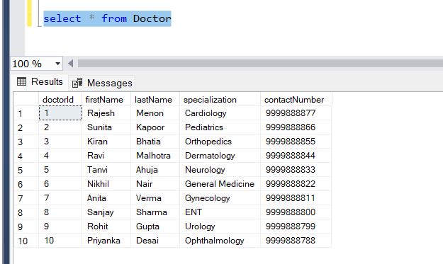

I have Define ‘Appointment Class` class with the following confidential attributes and inserted some rows to it.

a. appointmentId

b. patientId

c. doctorId

d. appointmentDate

e. description

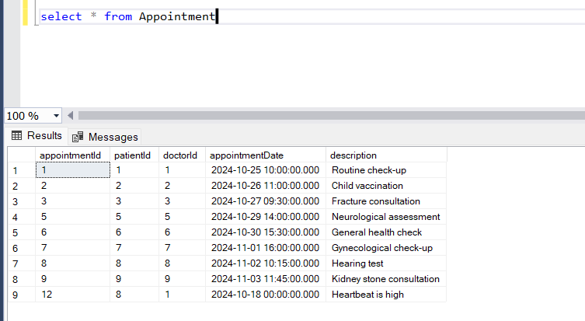

Defined HospitalServiceImpl class and implemented all the below methods IHospitalServiceImpl

1. get_appointment_by_id
2. get_appointments_for_patient
3. get_appointments_for_doctor
4. schedule_appointment
5. get_all_doctors
6. update_appointment
7. cancel_appointment

**WORKFLOW IS GIVEN BELOW**

**Option 1: Schedule Appointment**

* **Actions:**
  + The system lists available doctors with their IDs, names, and specializations.
  + The user enters the appointment ID, patient ID, doctor ID, appointment date, and description.
  + The system creates an Appointment object and calls the schedule_appointment() method.
  + If successful, the system confirms the appointment. If an error occurs, it displays an error message.

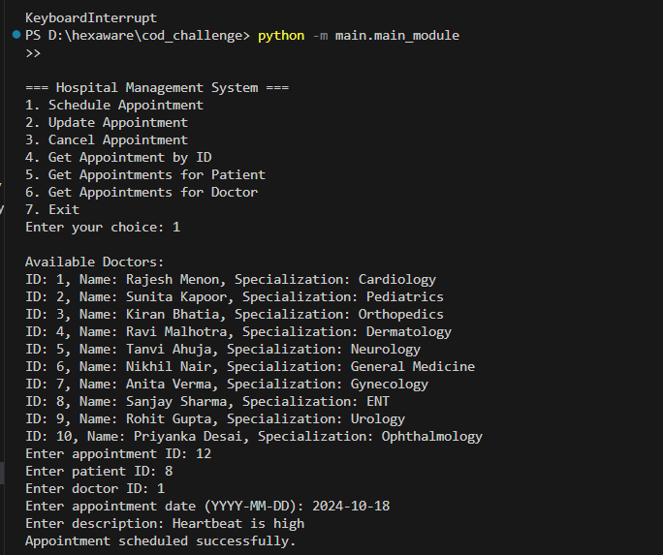

**Option 2: Update Appointment**

* **Actions:**
  + The user enters the appointment ID to update.
  + New patient ID, doctor ID, appointment date, and description are provided.
  + The system creates an updated Appointment object and calls the update_appointment() method.
  + If successful, the system confirms the update. If unsuccessful, an error message is shown.

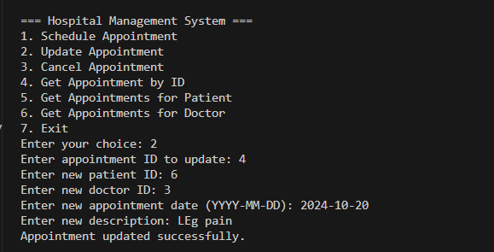

**Option 3: Cancel Appointment**

* **Actions:**
  + The user enters the appointment ID to cancel.
  + The system calls cancel_appointment() method.
  + If successful, it confirms the cancellation. If unsuccessful, it shows an error message.

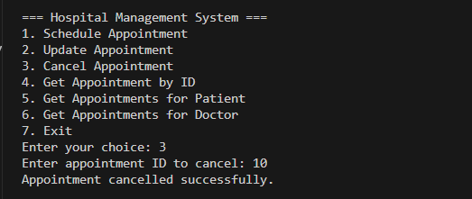

**Option 4: Get Appointment by ID**

* **Actions:**
  + The user enters the appointment ID.
  + The system retrieves the appointment using get_appointment_by_id().
  + If the appointment is found, it displays the details. If not, it raises a PatientNotFoundException and shows an error message.

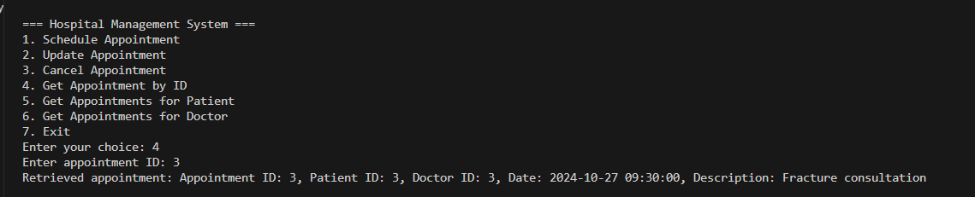

**Option 5: Get Appointments for Patient**

* **Actions:**
  + The user enters the patient ID.
  + The system retrieves all appointments for the patient using get_appointments_for_patient().
  + If appointments are found, they are listed. If no appointments exist or the patient doesn't exist, appropriate messages are shown.

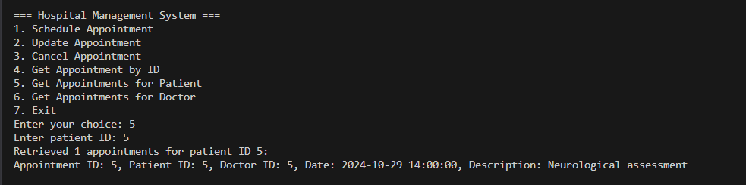

**Option 6: Get Appointments for Doctor**

* **Actions:**
  + The user enters the doctor ID.
  + The system retrieves all appointments for the doctor using get_appointments_for_doctor().
  + If appointments are found, they are listed. If not, a message is displayed.

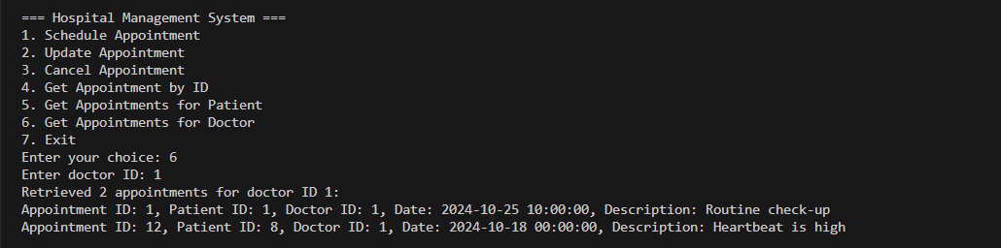

**Option 7: Exit**

* **Action:**
  + The system displays a message ("Your health is an investment not an expense") and exits the application.

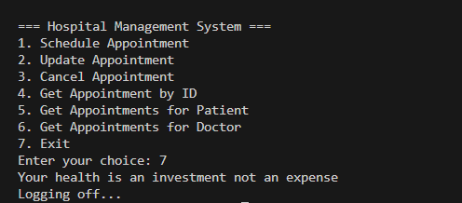

**PatientNumberNotFoundException** :throw this exception when user enters an invalid patient

number which doesn’t exist in db. And this is handled using PatientNotFoundException in my code.

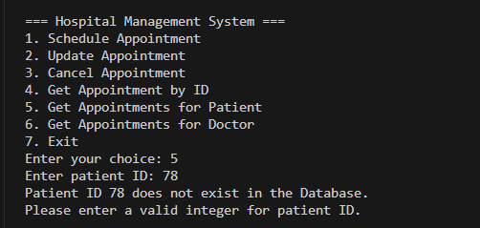

Finally I have made a log for this:  
